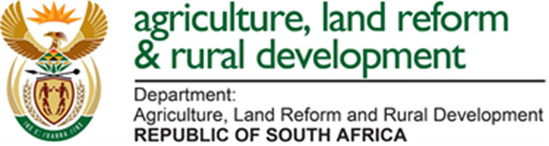

BANANAS MAXIMUM RESIDUE LIMITS (MRL) LIST – Updated JUNE 2021
ACTIVES | RSA | CODEX
Ametryn | 0.20 | -
Benomyl/Carbendazim | 1.00 | 0.2
Bromopopylate | 3.00 | -
Cadusafos | 0.05 | 0.01
Chlorpyrifos | 1.00 | 2.00
Clothianidin | 0.02 | 0.02
Dichlorvos | 0.10 | -
Dicofol | 5.00 | -
Ethylene bisdithiocarbamates | 3.00 | 2.00
Fenamiphos | 0.05 | 0.05
Fosthiazate | 0.05 | -
Mercaptothion/Malathion | 2.00 | -
Oxamyl | 0.05 | -
Prochloraz | 2.00 | -
Propiconazole | 0.10 | 0.10
Sulphur | 50.00 | -
Thiamethoxam | 0.05 | 0.02
Thiabendazole | 3.00 | 5.00
Triadimefon | 0.50 | 1.00
Triazophos | 2.00 | -

- Means there is no established MRL value

